IMPORTANT RECALL NOTICE INFORMATION

April 21, 2022

Dear,
I hope this finds you well. I’m writing now because the manufacturer of the implant used in your knee replacement has issued a recall of one component of that implant. Although the rate of implant failure is very low, HSS is notifying and helping affected HSS patients understand the recall, and the signs and symptoms that may indicate the need for medical assessment and attention.
As you may know, implantation of your knee prosthesis involved the utilization of a polyethylene tibial liner or insert. The liner used in your surgery was manufactured by Exactech, Inc.
Exactech has issued a recall of the tibial insert that you received, due to potential premature wear in some patients.

Explanation of the recall:
As shown in the diagram below, a standard knee replacement has four parts:
- The femoral component (this is the metal piece that attaches to your thigh bone, also known as your “femur”)
- The tibial tray (this is the metal piece that fits into your shin bone, also known as your “tibia”)
- The patellar component (this is the piece of plastic that fits onto your kneecap, also known as the patella)
- The tibial polyethylene (plastic) insert (this is the plastic that fits between the femoral component and tibial component and acts as the new cushion or cartilage for your replaced knee joint)
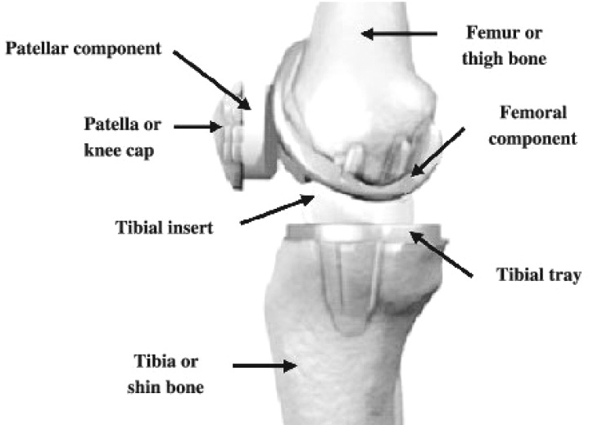
During a recent review of its knee implant manufacturing process, Exactech learned of an issue with the packaging of the plastic insert which can allow oxygen from the air into the plastic insert prior to it being implanted. If a large amount of oxygen diffuses into the plastic insert while it’s being stored and before it is implanted, this can lead to a process called oxidation, which can cause the plastic to wear out earlier than expected or to become damaged after it is implanted into the patient’s body.

What Should You Do?
The symptoms of premature wear include unusual and persistent pain, swelling, redness, stiffness of the knee, and/or instability.
If you do not have any of these symptoms, you can just follow-up at your regularly scheduled time interval. We advise that you have a knee x-ray if you have not had one in the past two years even if you do not have any symptoms at this time. We expect the percentage of patients to develop any problems due to the issues identified in this recall is extremely low.
If you are experiencing any of these symptoms, and/or have not had an x-ray in more than two years, please contact the HSS Patient Access special hotline set up for this recall at 1-855-482-1309 Monday through Friday from 9:00 a.m. to 6:30 p.m. Eastern Time (excluding major U.S. holidays). A patient access specialist will ask you some questions about your knee and if appropriate, refer you for clinical evaluation and other testing such as an x-ray, if necessary.

Claims Administration for Out-of-Pocket Costs:
Exactech is committed to addressing recall-related out-of-pocket expenses, and has partnered with Broadspire, a Third- Party Administrator, to manage the claims reimbursement process. Please contact the Exactech-Broadspire Helpline at (888) 912-0403 to initiate the claims process. Please note that when you call the helpline, you will be asked to verify that you have received an Exactech implant included in the recall. You will also be asked for: name of your surgeon, date of knee replacement surgery and insert serial #; this information is noted at the bottom of this page.
Additional information about these services and Frequently Asked Questions can be found on the Exactech website at: https://www.exac.com/recall
If you have any questions regarding Exactech knee products or manufacturing, please call Exactech directly at the following United States phone number +1 888 912 0403.
Sincerely,
Mathias P.G. Bostrom, MD, FACS
Chief, Adult Reconstruction and Joint Replacement Service

Information regarding your surgery:

